**setup steps of camera on raspberry pi**

Raspberry pi website assistant:

<https://projects.raspberrypi.org/en/projects/getting-started-with-picamera>

introduction video for streamlining:

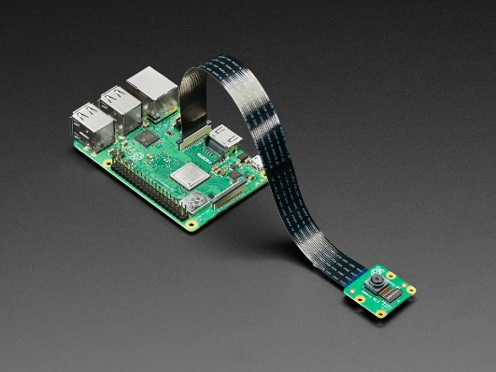<https://www.youtube.com/watch?v=fdgurREGhbc&t=28s&ab_channel=GaryExplains>

the cam will install to raspberry pi due a flat cable:

**But** make sure the Raspberry Pi is disconnected from power when installing the camera.

We can use any type of camera and install it due any protocol connection like Ethernet,HDMI, any method can be used.

Using raspberry pi configuration and command window to complete the connection:

<https://www.raspberrypi.com/software/raspberry-pi-desktop/>

commands used to connection:

<https://www.rickmakes.com/monitoring-an-ip-camera-using-a-raspberry-pi-no-internet/>

**connecting with mobile phone`s camera:**

**Step 1: Install DroidCam on Your Mobile.**

App. Mobile:

<https://play.google.com/store/apps/details?id=com.pas.webcam>

or

<https://play.google.com/store/apps/details?id=com.dev47apps.droidcam>

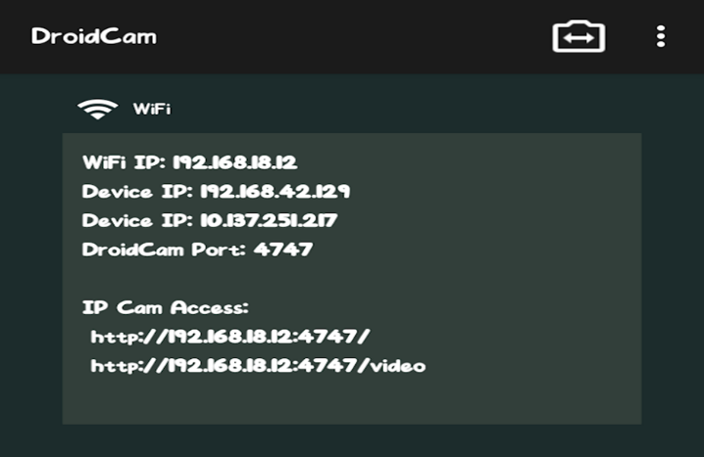open the application on your mobile to see the IP cam access information. This information will be used to access your mobile camera from the Raspberry Pi device.

**Step 2: Access Mobile Camera on Raspberry Pi**

To access the mobile camera on Raspberry Pi, open the browser on your Raspberry Pi and enter the IP address that appears on DroidCam application below the IP Cam Access section.

Then we can take a video record or screenshot using commands.

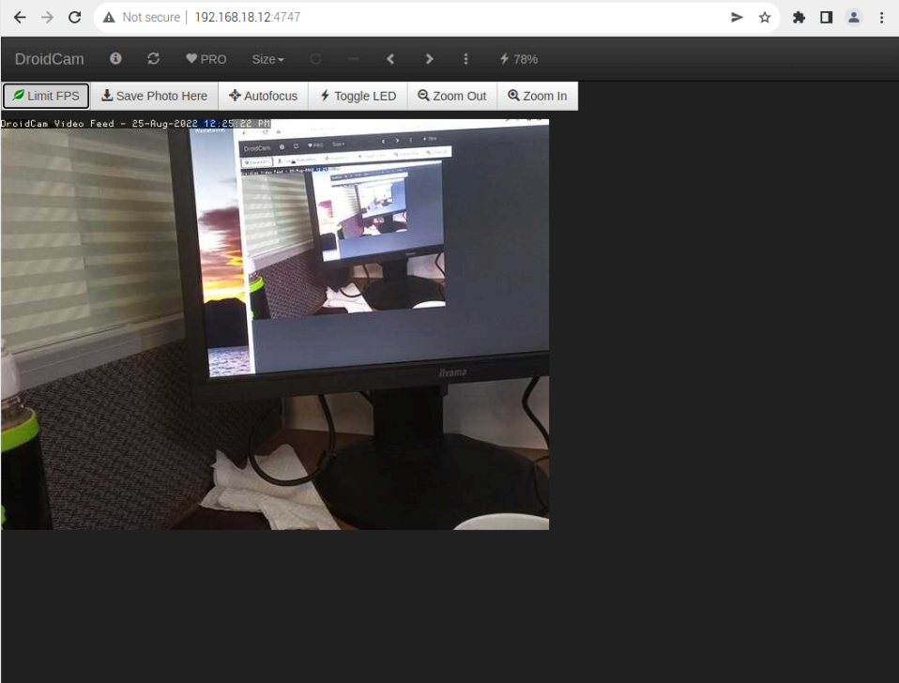

Same method with other program and commands:

<https://www.dexterindustries.com/howto/walk-through-and-tutorial-on-how-to-connect-the-raspberry-pi-and-mobile-phone-connect-raspberry-pi-mobiletablet/>